[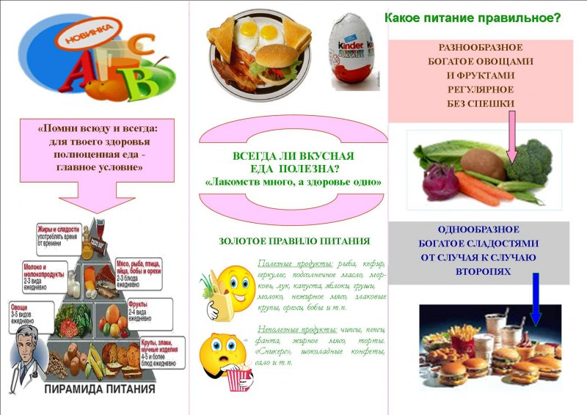](https://abrakadabra.fun/uploads/posts/2022-03/1647240210_1-abrakadabra-fun-p-buklet-pravilnoe-pitanie-1.jpg)

[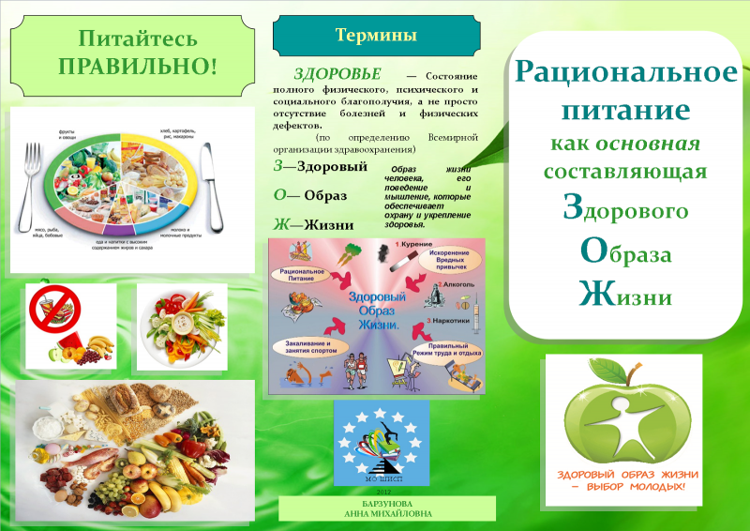](https://abrakadabra.fun/uploads/posts/2022-03/1647240158_3-abrakadabra-fun-p-buklet-pravilnoe-pitanie-3.png)

[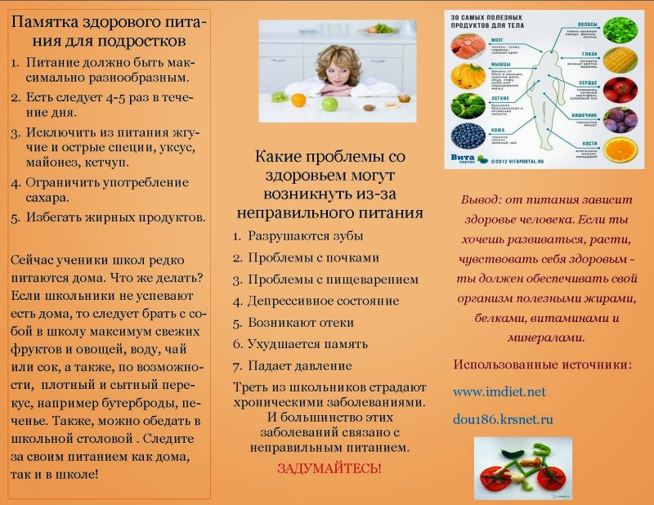](https://abrakadabra.fun/uploads/posts/2022-03/1647240203_4-abrakadabra-fun-p-buklet-pravilnoe-pitanie-4.jpg)

[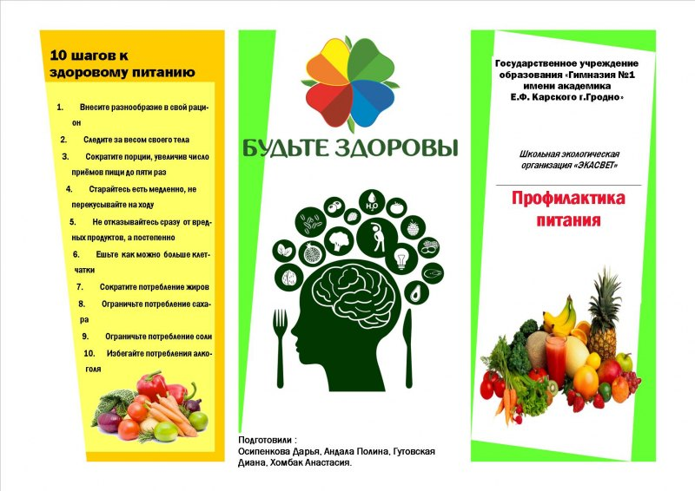](https://abrakadabra.fun/uploads/posts/2022-03/1647240215_6-abrakadabra-fun-p-buklet-pravilnoe-pitanie-6.jpg)

[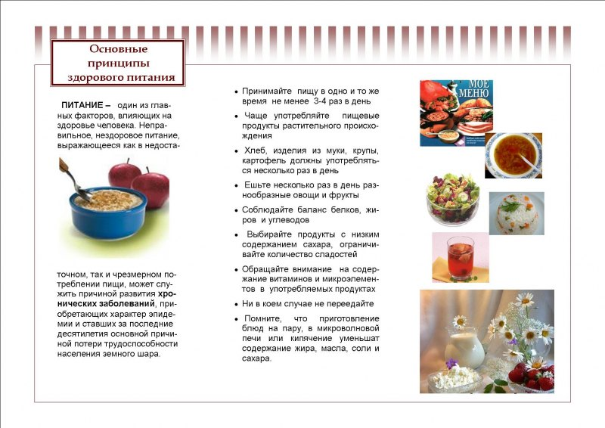](https://abrakadabra.fun/uploads/posts/2022-03/1647240170_7-abrakadabra-fun-p-buklet-pravilnoe-pitanie-7.jpg)

[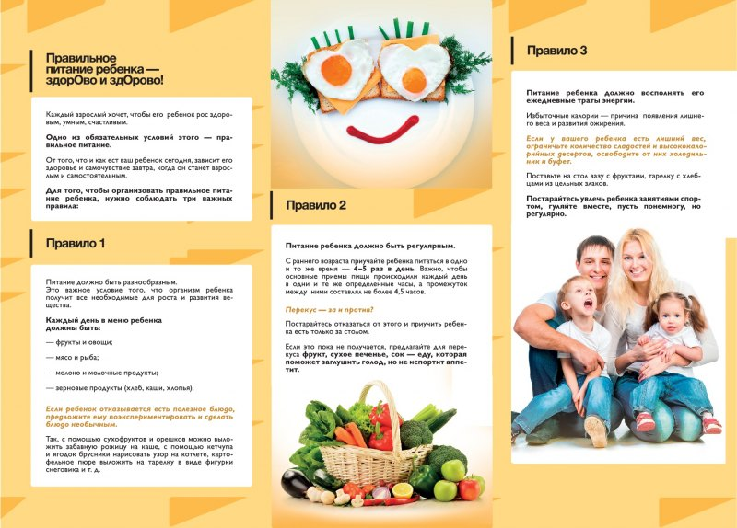](https://abrakadabra.fun/uploads/posts/2022-03/1647240143_8-abrakadabra-fun-p-buklet-pravilnoe-pitanie-8.jpg)

[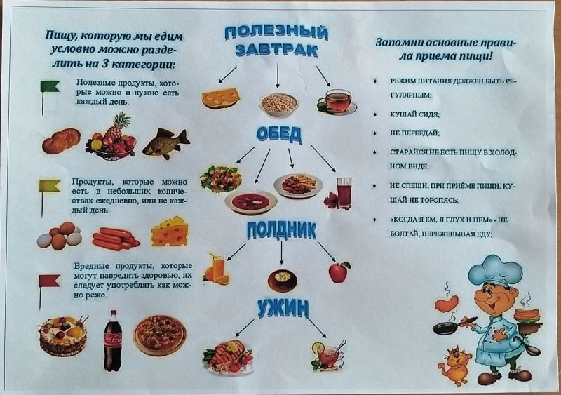](https://abrakadabra.fun/uploads/posts/2022-03/1647240185_9-abrakadabra-fun-p-buklet-pravilnoe-pitanie-9.jpg)

[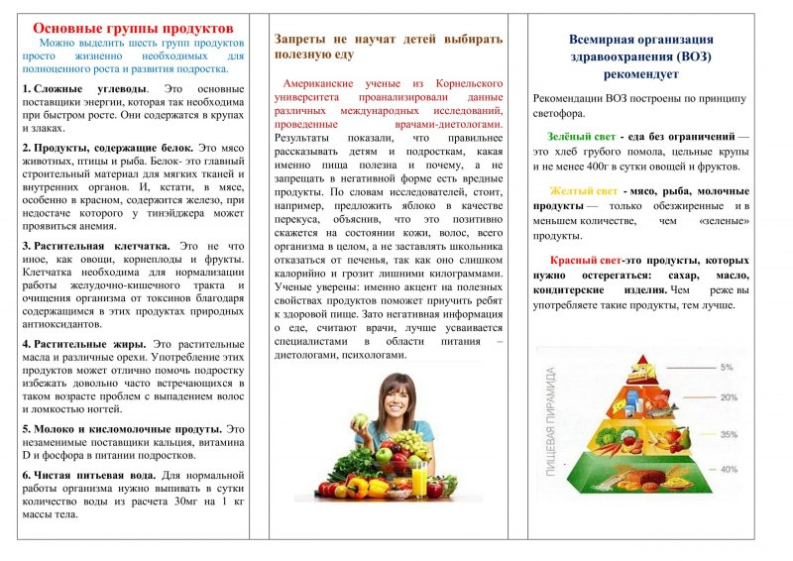](https://abrakadabra.fun/uploads/posts/2022-03/1647240137_10-abrakadabra-fun-p-buklet-pravilnoe-pitanie-11.jpg)

[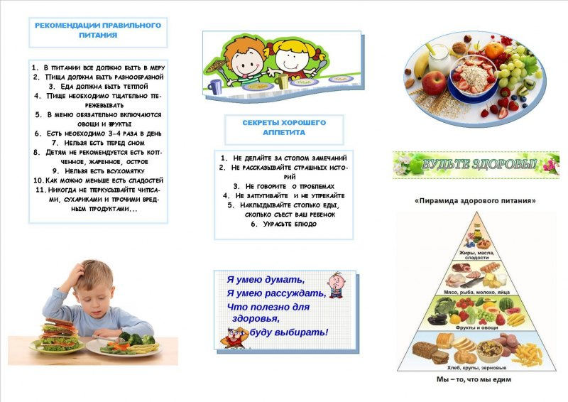](https://abrakadabra.fun/uploads/posts/2022-03/1647240211_12-abrakadabra-fun-p-buklet-pravilnoe-pitanie-13.jpg)

[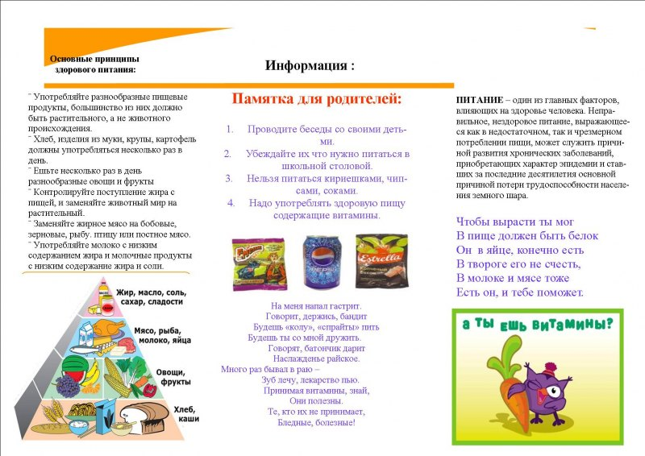](https://abrakadabra.fun/uploads/posts/2022-03/1647240145_13-abrakadabra-fun-p-buklet-pravilnoe-pitanie-14.jpg)

[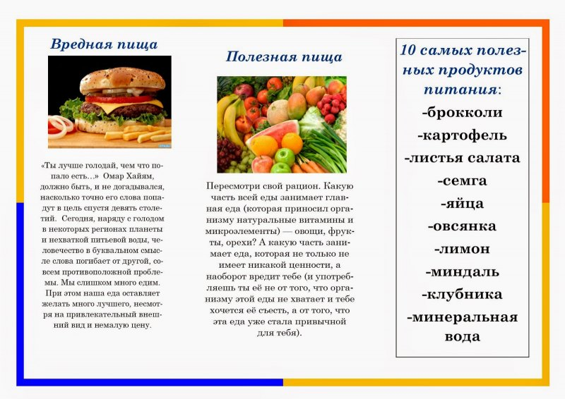](https://abrakadabra.fun/uploads/posts/2022-03/1647240211_14-abrakadabra-fun-p-buklet-pravilnoe-pitanie-15.jpg)

[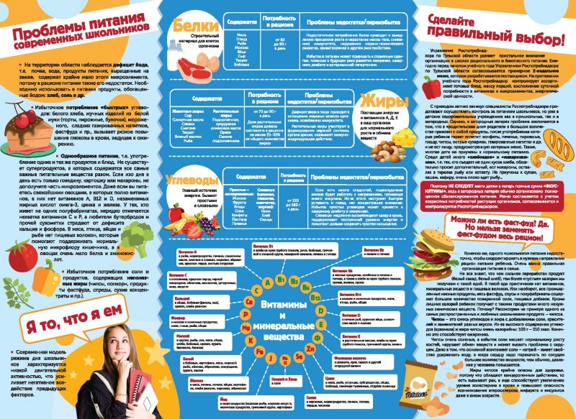](https://abrakadabra.fun/uploads/posts/2022-03/1647240218_16-abrakadabra-fun-p-buklet-pravilnoe-pitanie-18.jpg)

[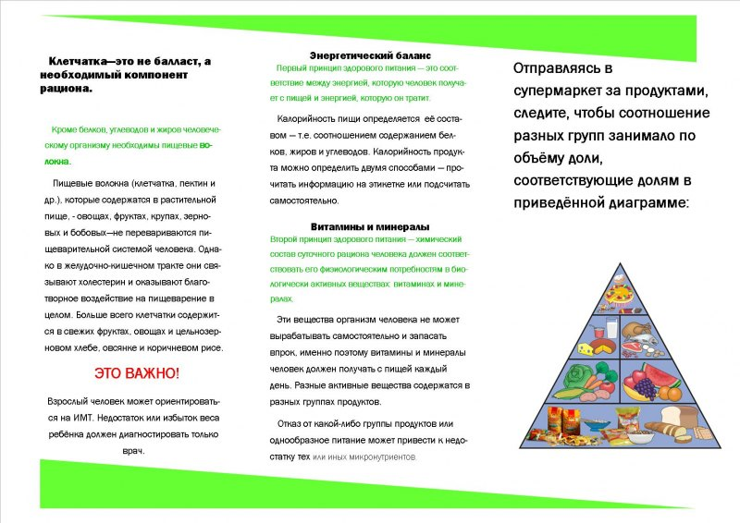](https://abrakadabra.fun/uploads/posts/2022-03/1647240182_17-abrakadabra-fun-p-buklet-pravilnoe-pitanie-20.jpg)